Website Planning & Documentation Report

1. Website Specifications
Website Name: Webb’s Motors
Website Introduction
Welcome to Webb’s Motors, your reliable destination for professional spray painting services in Gaborone. Our website provides an easy way to explore our services, view our work, and get in touch with us.
We are dedicated to delivering quality workmanship and excellent customer service, ensuring your vehicle is restored to its best condition.
Website Objective:
The objective of the website is to provide an online platform for Webb’s Motors to showcase its spray painting services, attract new customers, and provide essential business information such as location, contact details, and services offered.
Website Goals:
1. To promote services such as spray painting
2. To increase customer inquiries
3. To provide easy access to contact details
4. To build a professional online presence
5. To showcase previous work
Target Audience:
Age: 18 years and above
Gender: All
Location: Gaborone and surrounding areas
Technical Ability: Basic to intermediate users as they will be able to fill out and submit the contact or feedback form, as well as browsing the website on different devices such as smartphones and computers.
Type of Website:
Business and Service Website

2. Information Design & Taxonomy
Site Map:
Home (index.html)
- About Us (about.html)
- Services (services.html)
- Gallery (gallery.html)
- Contact (contact.html)
- Feedback (feedback.html)
Navigation Structure:
The website will use a top navigation bar visible on all pages. Users can access all pages within 2–3 clicks.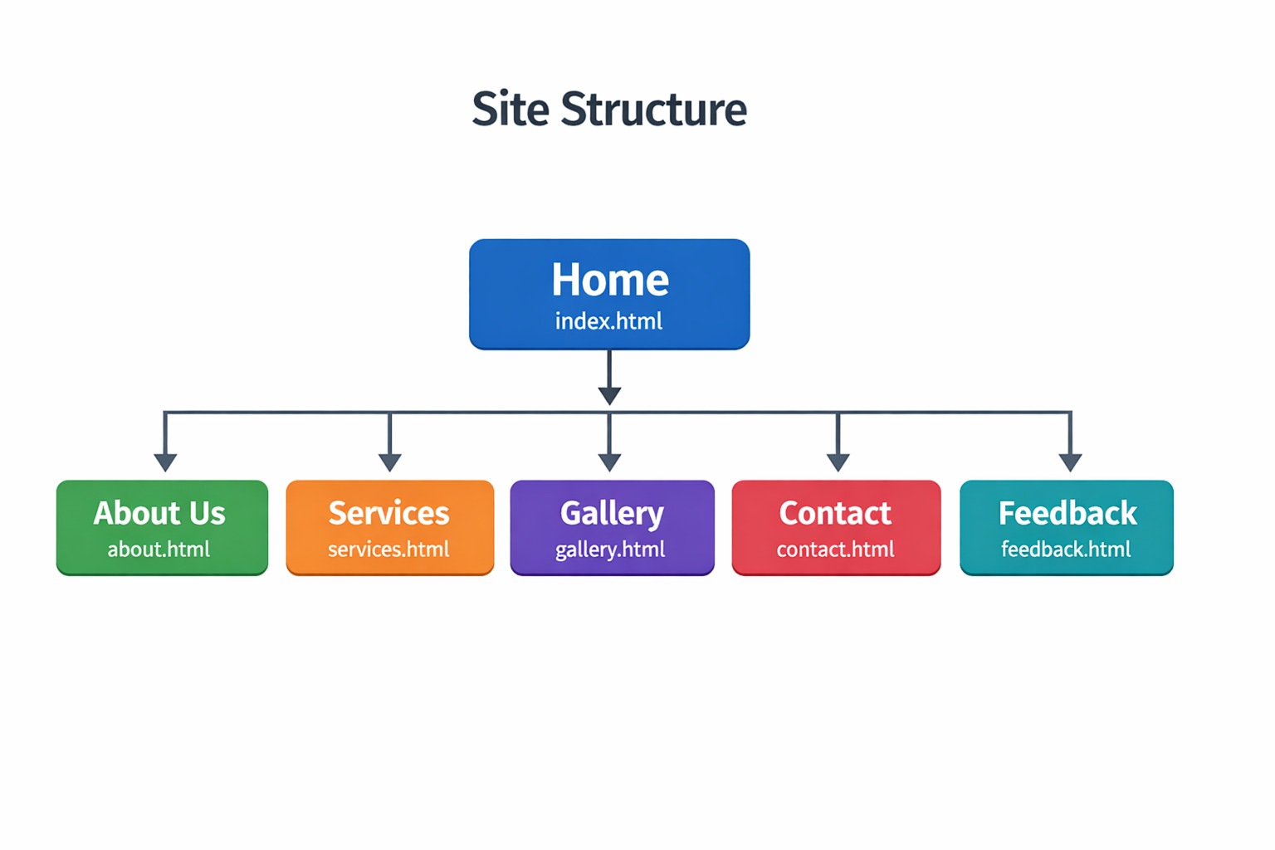
Content Organization:
- Home: Introduction and overview
- About: Company background
- Services: Services offered by the company
- Gallery: Images of work done by the company
- Contact: Contact form to allow users to easily communicate with Webb’s Motors
- Feedback: Customer feedback
User Flow:
Users start on the Home page, navigate to Services or Gallery, then proceed to Contact to submit inquiries.

3. Technical Brief
Technologies Used: The Webb’s Motors website uses a combination of web technologies to create a functional, responsive, and user-friendly platform tailored to showcase automotive services.
1. HTML5 (HyperText Markup Language): HTML5 is used to structure all the pages of the website. For example, the Home page uses HTML to define the navigation bar, hero section, and service previews. The Contact page uses HTML forms to collect user information such as name, email, and message. Each page (About, Services, Gallery, Contact, and Feedback) is built using HTML to organize content clearly and ensure easy navigation.
2. CSS3 (Cascading Style Sheets): CSS3 is used to style the website and create a professional appearance that reflects the automotive theme of Webb’s Motors. It is applied to design elements such as the navigation bar, service cards, and gallery layout. CSS is also used to ensure consistency across all pages and to make the website responsive, allowing users in Gaborone and surrounding areas to access it easily on both mobile devices and desktops.
3. Bootstrap: Bootstrap is used to improve the layout and responsiveness of the website. It helps in structuring pages like the Services page, where services are displayed in a grid format, and the Contact page, where the form and contact details are aligned neatly. Bootstrap components such as buttons, grids, and navigation bars help create a clean and modern interface without extensive custom coding.
4. JavaScript: Bootstrap is used to improve the layout and responsiveness of the website. It helps in structuring pages like the Services page, where services are displayed in a grid format, and the Contact page, where the form and contact details are aligned neatly. Bootstrap components such as buttons, grids, and navigation bars help create a clean and modern interface without extensive custom coding.
Development Tools:
1. Notepad++: Code editor
2. GitHub: Version control
3. GitHub Pages: Hosting
Graphic Tools:
- GIMP / Canva: Image editing and design
Browser Compatibility:
Tested on Chrome, Firefox, Opera, and mobile devices.

4. Page template design

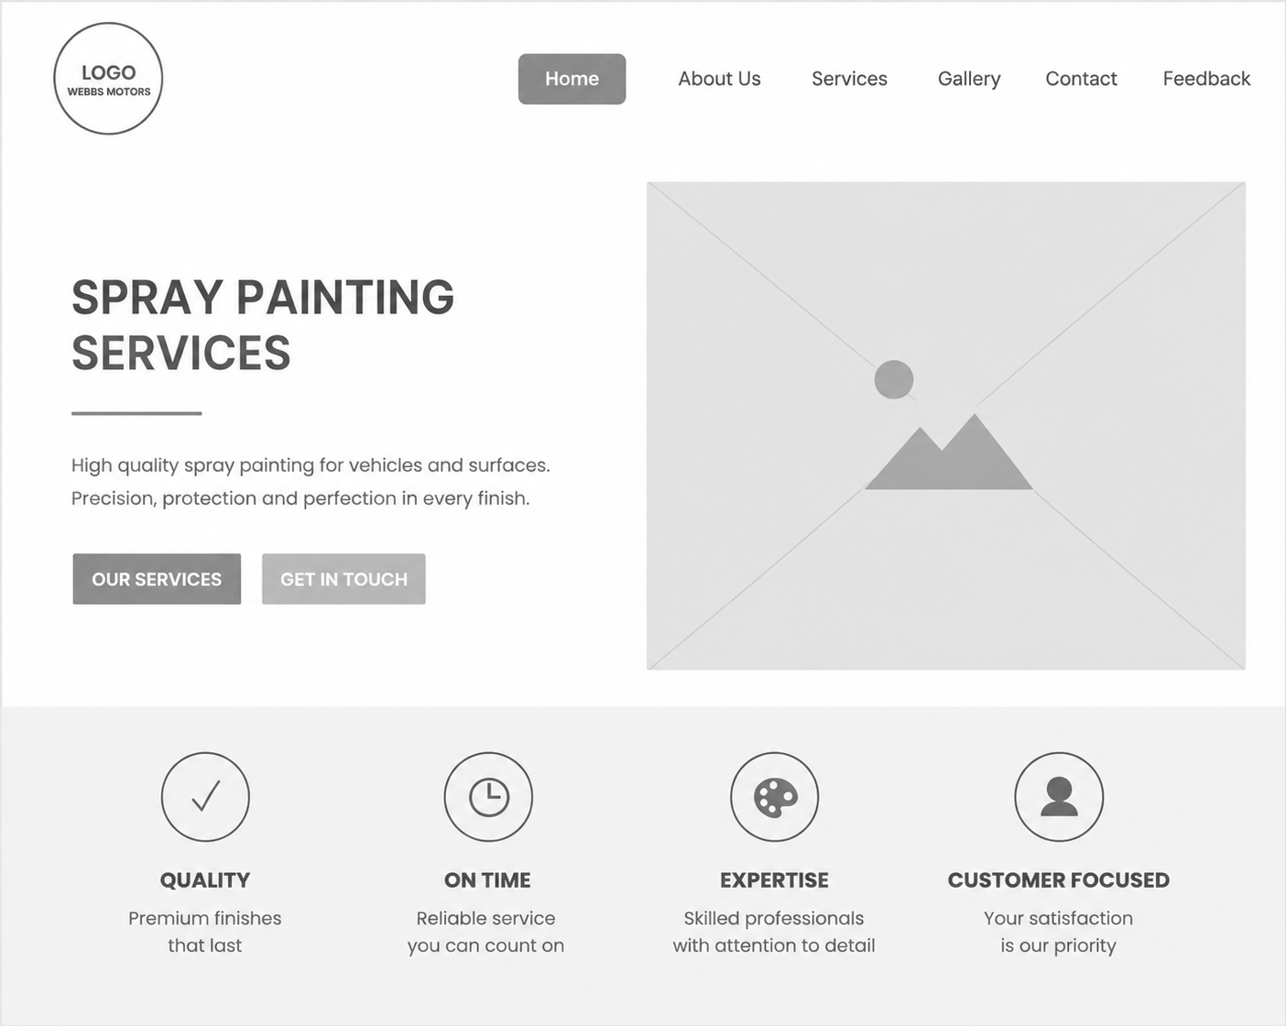
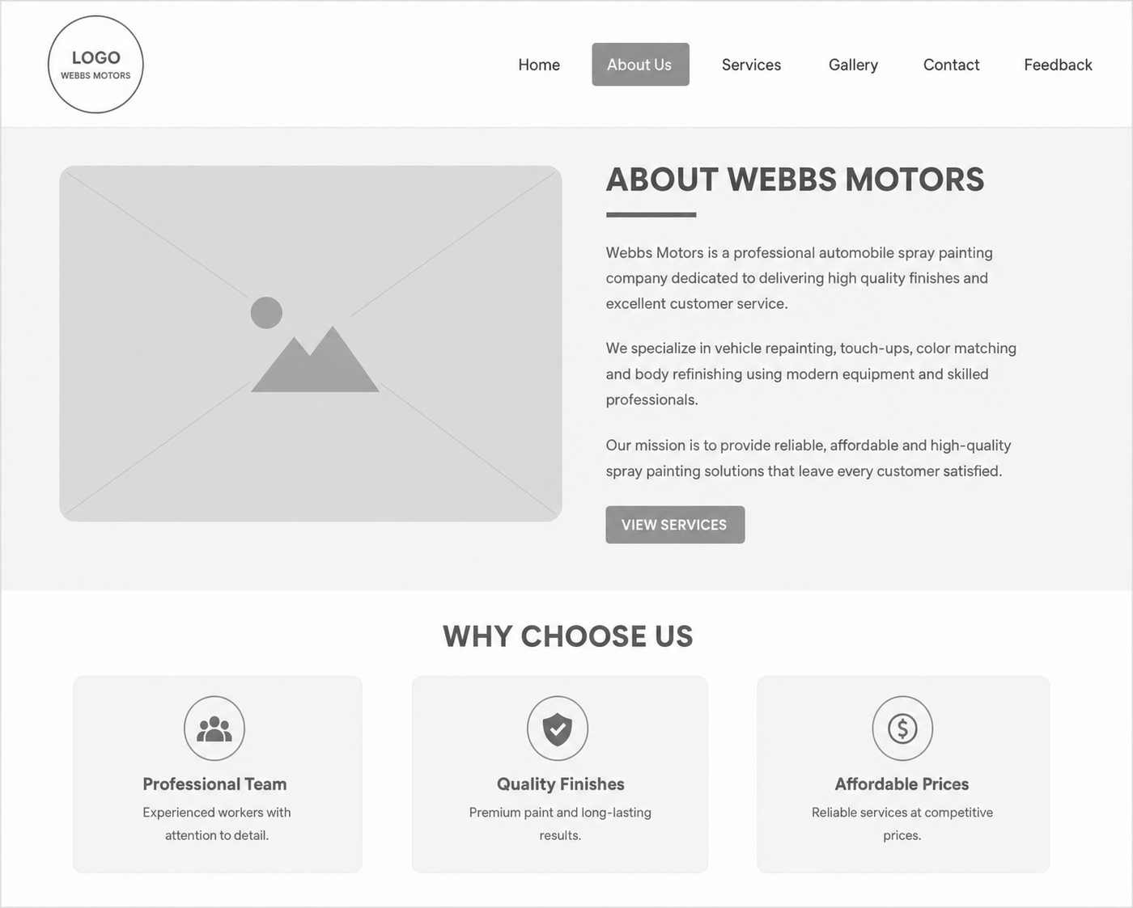
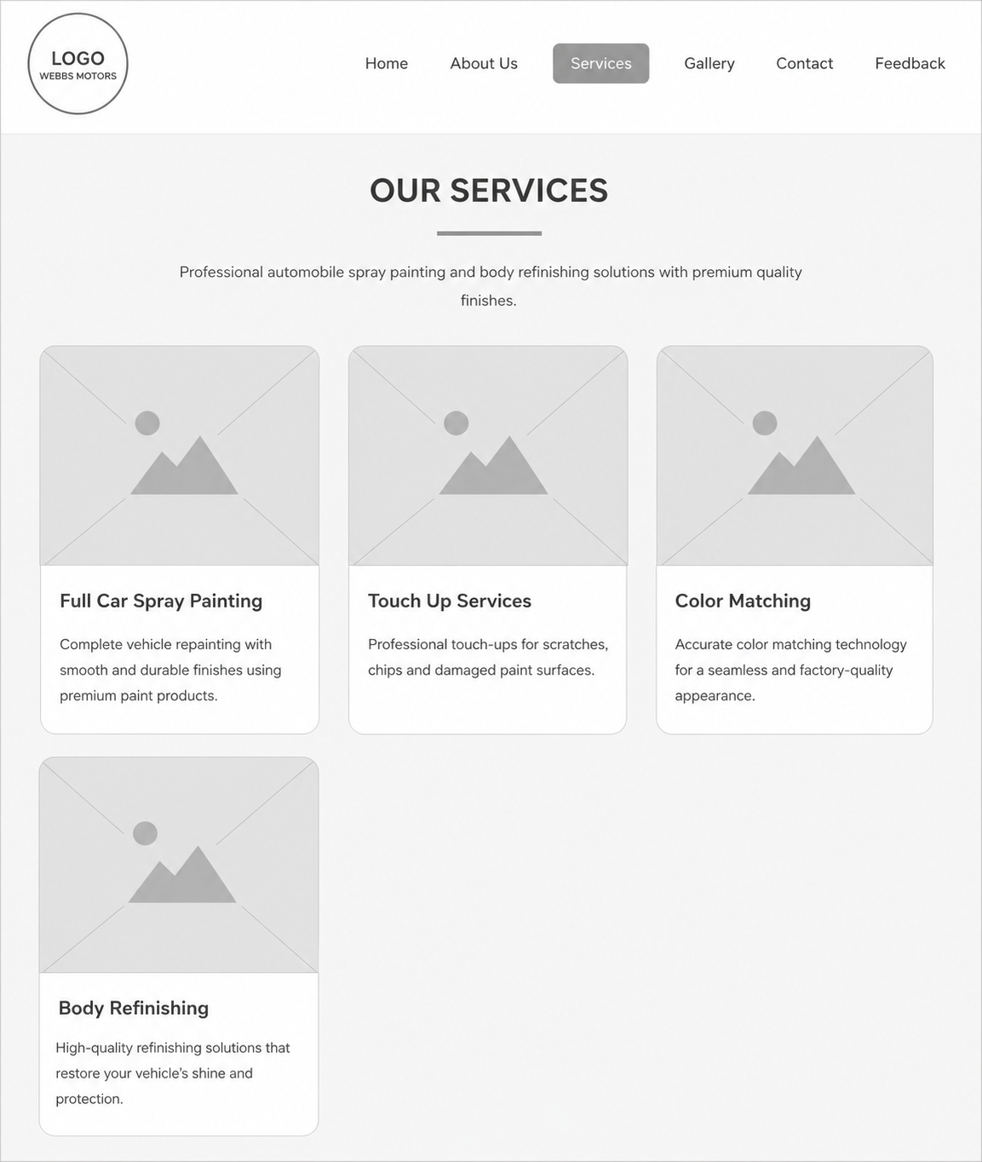 .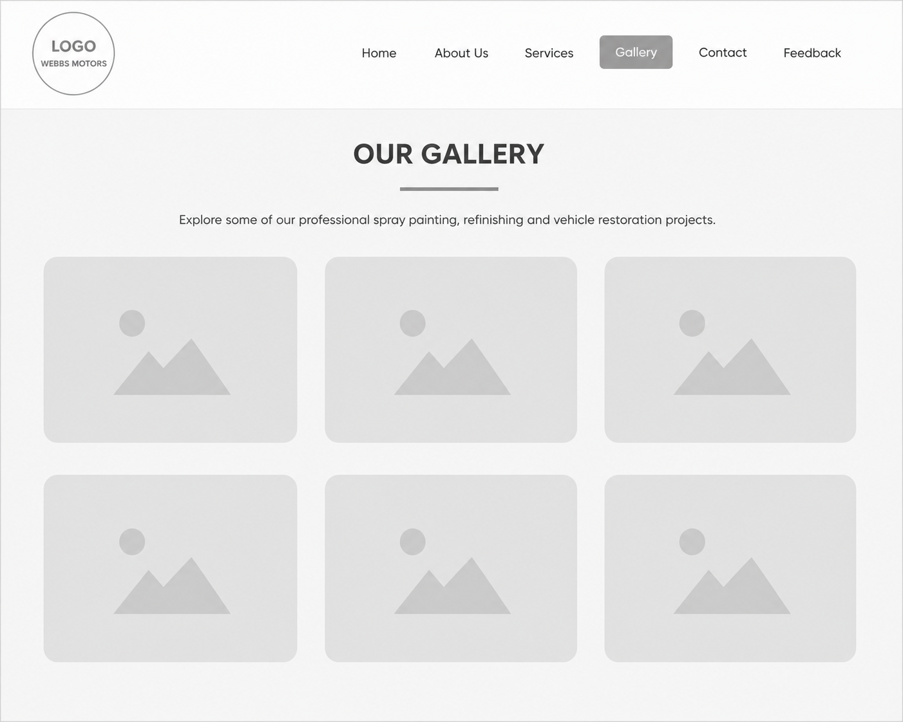 .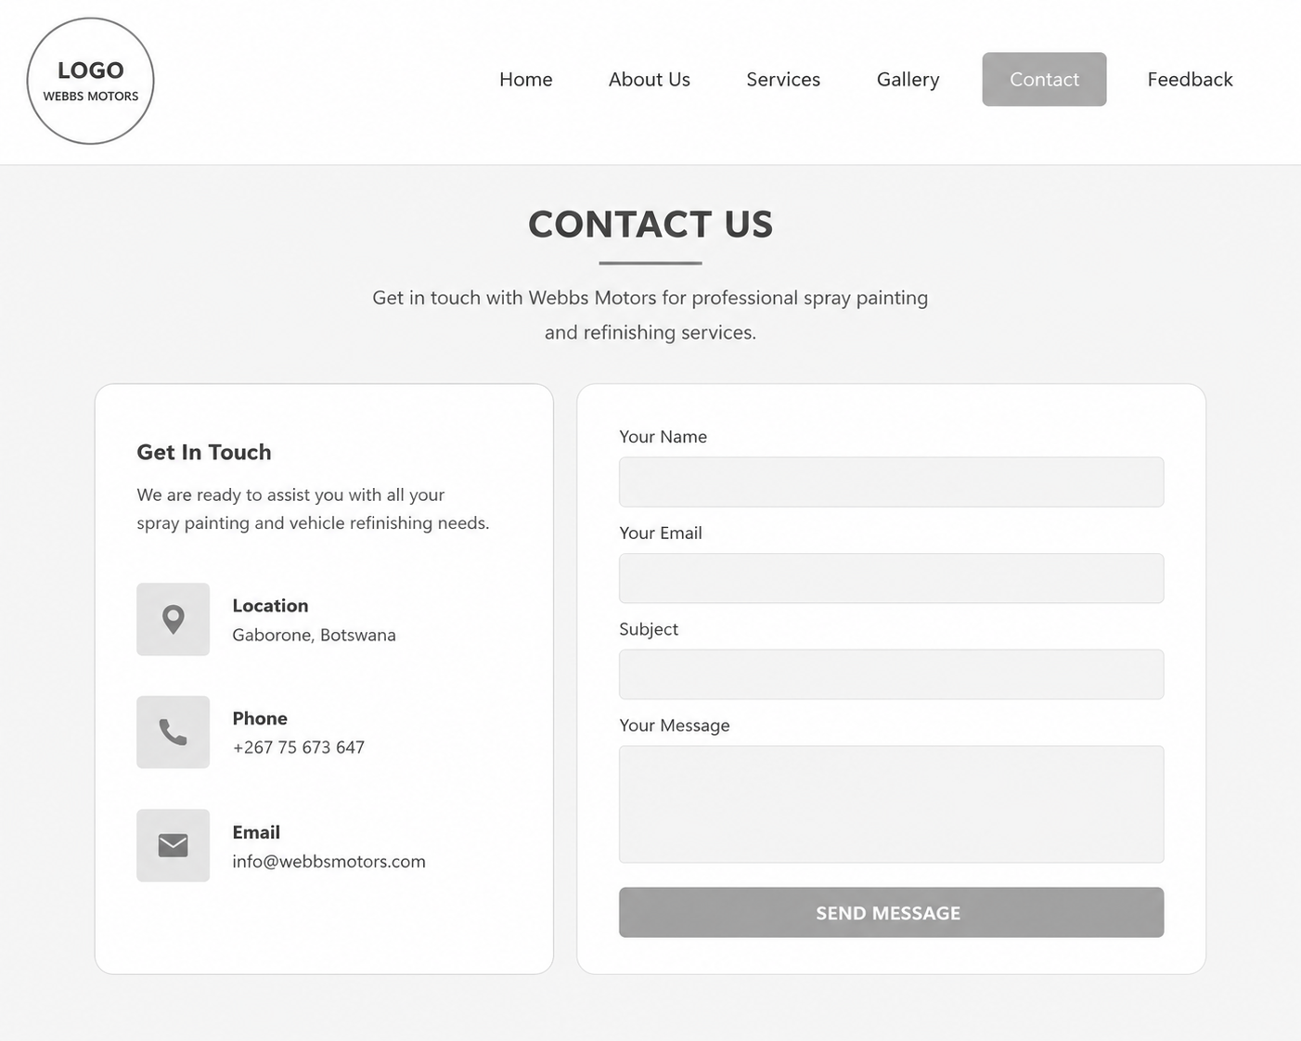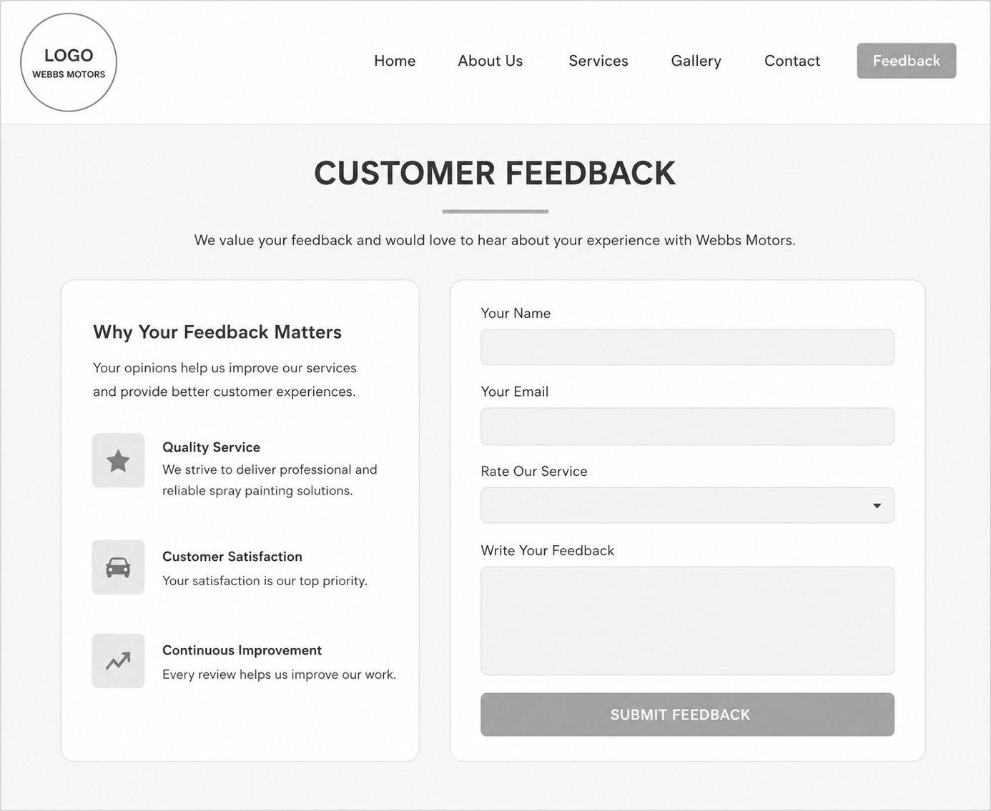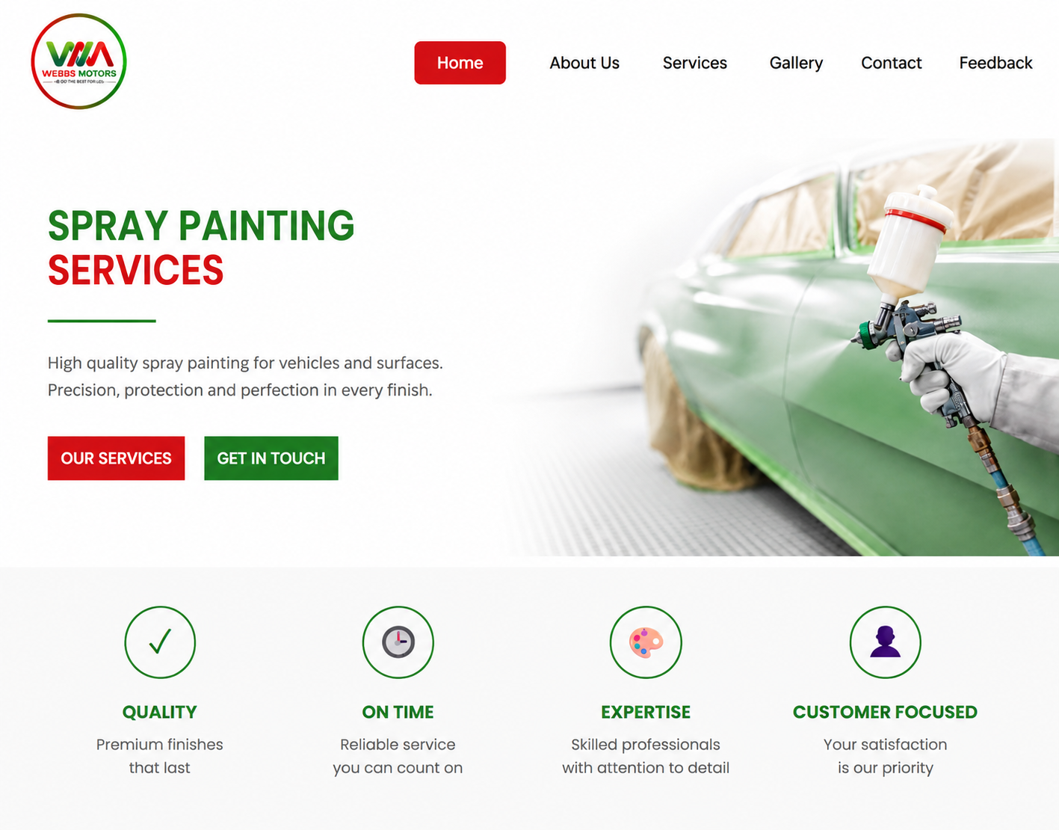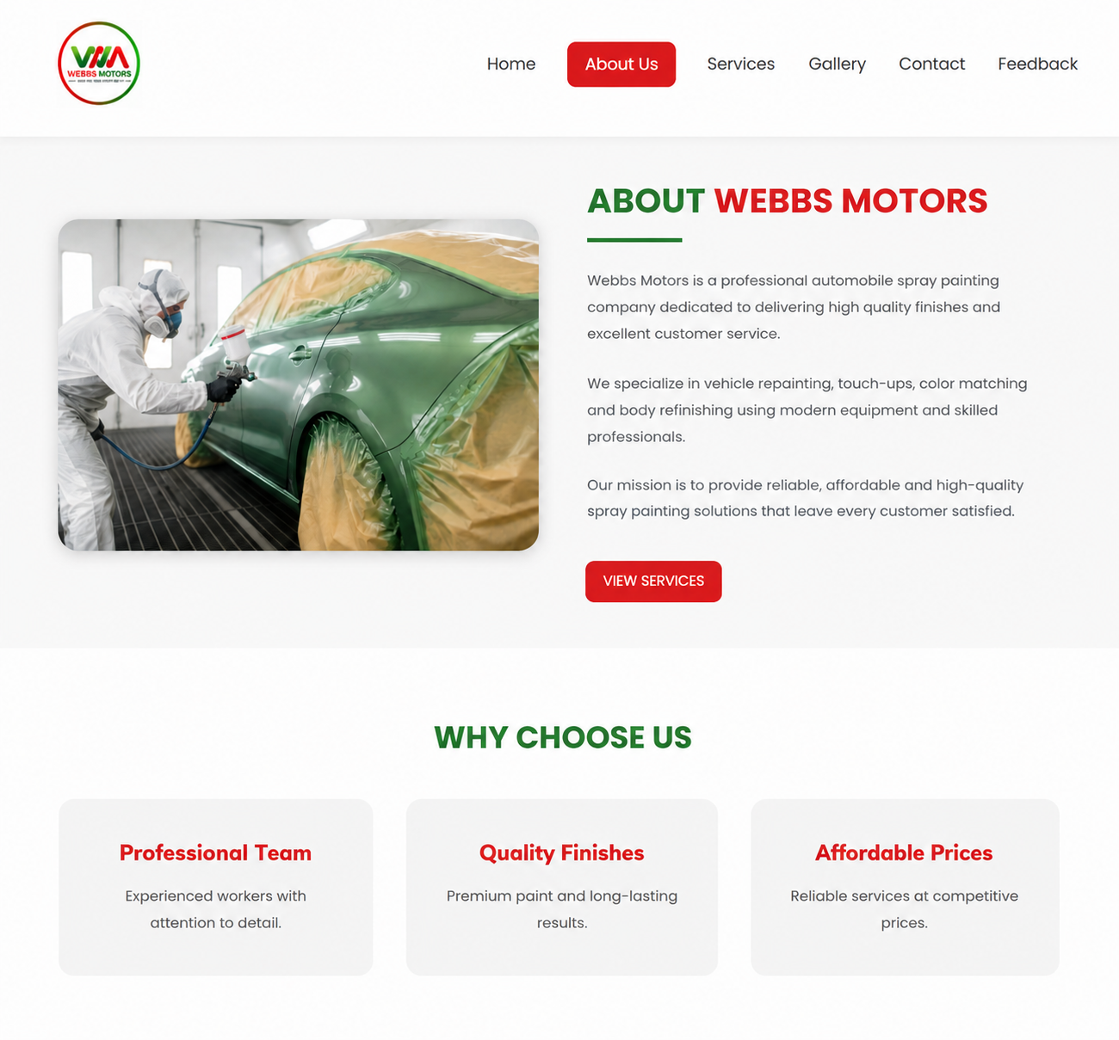

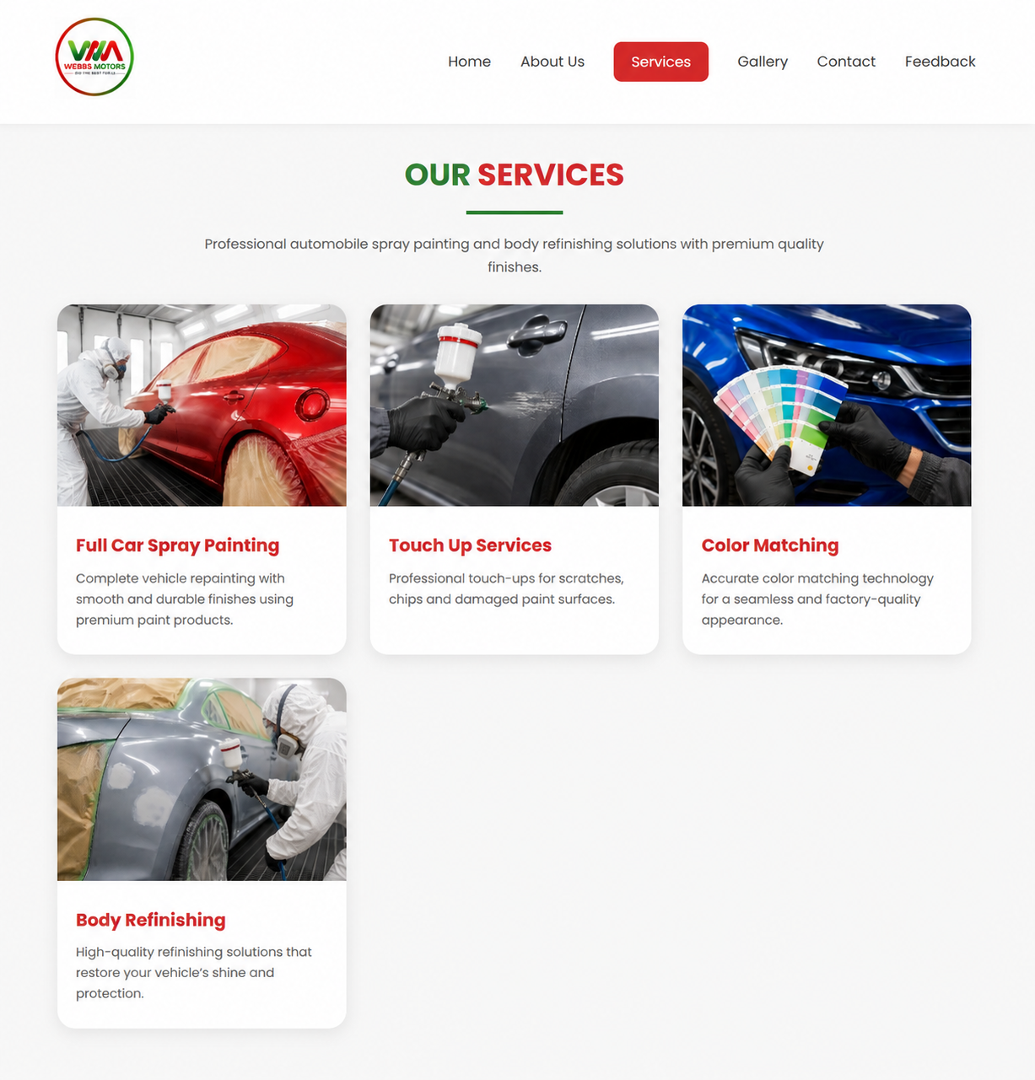

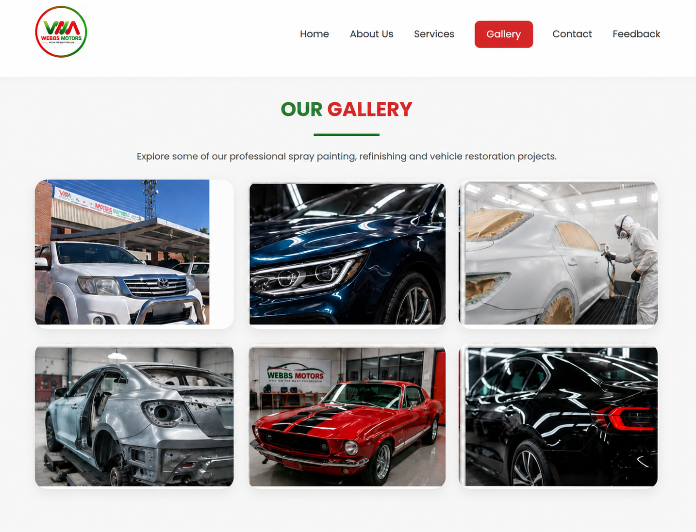

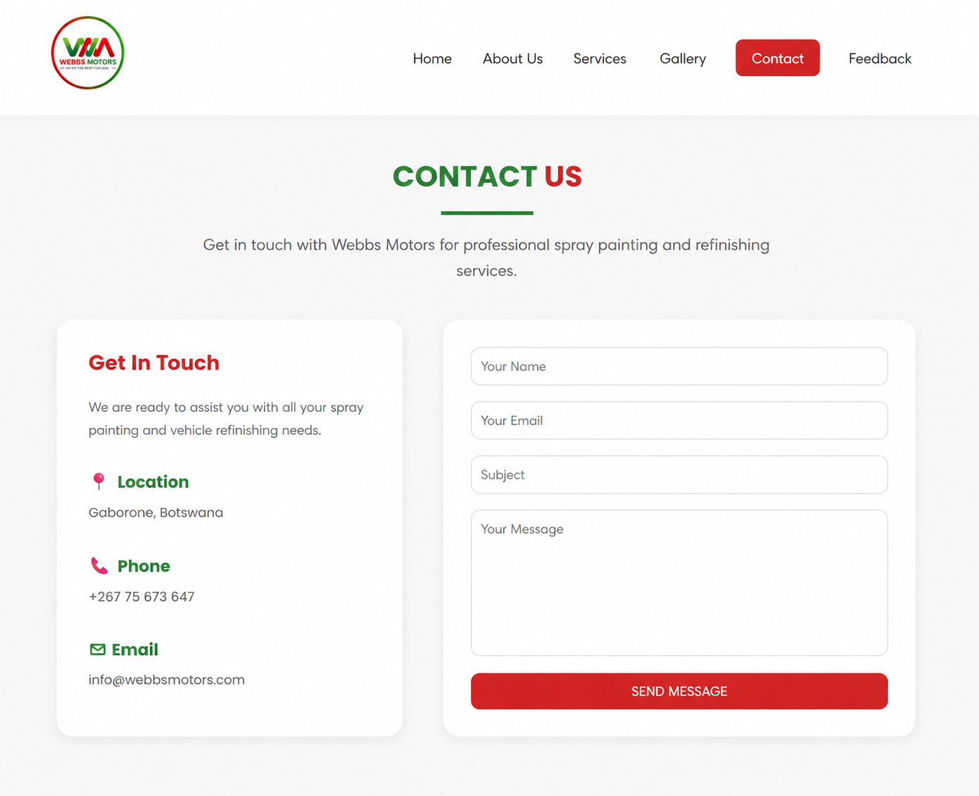

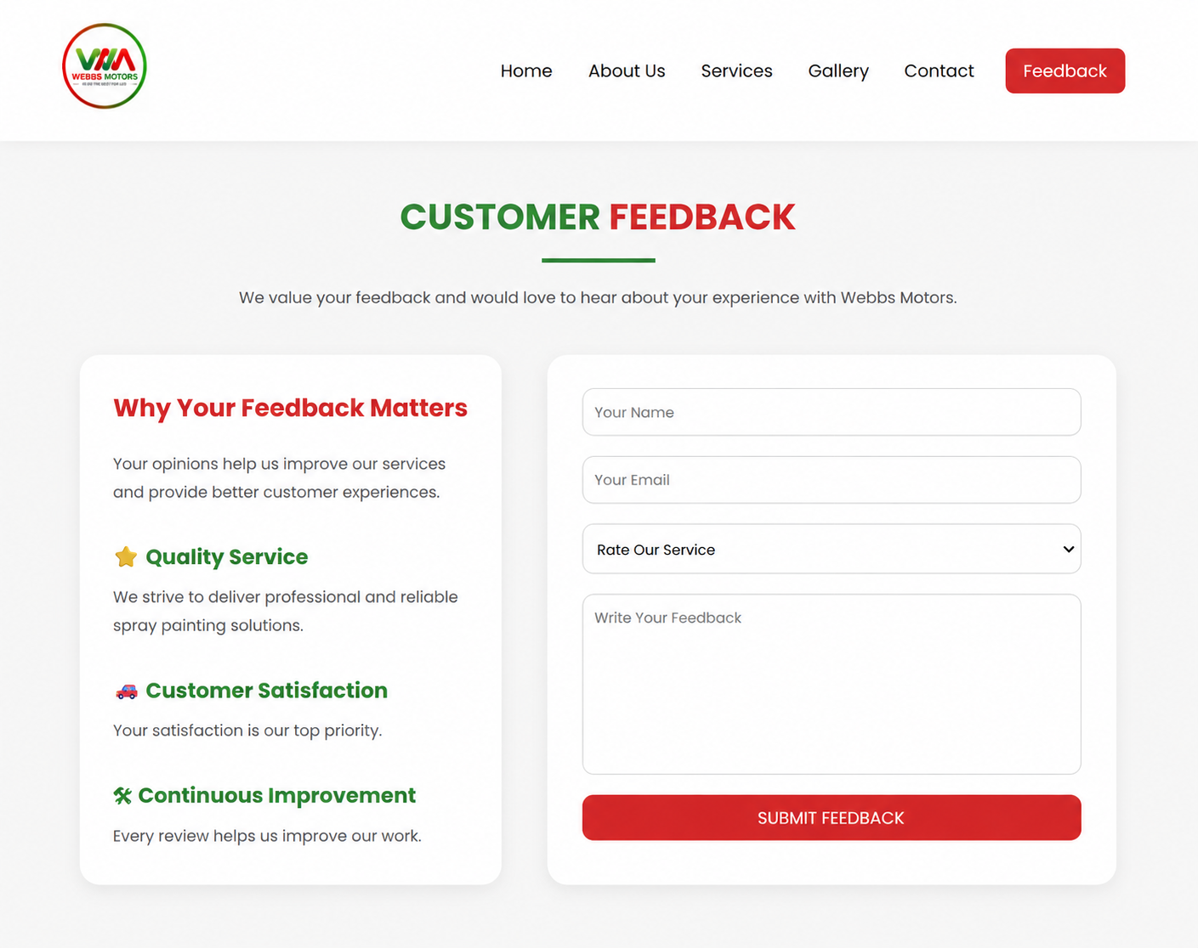

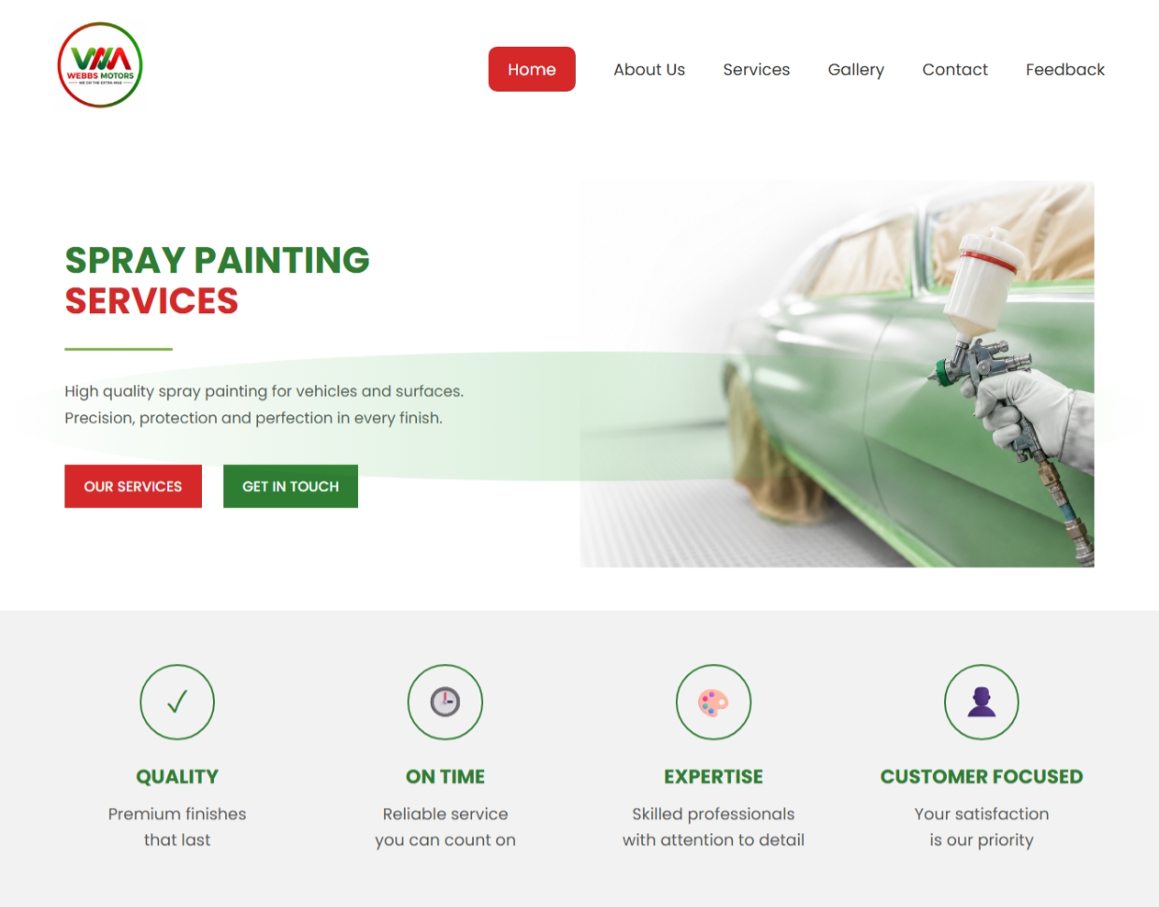The website was tested on google chrome and it functioned properly which indicated that it works properly on laptops.

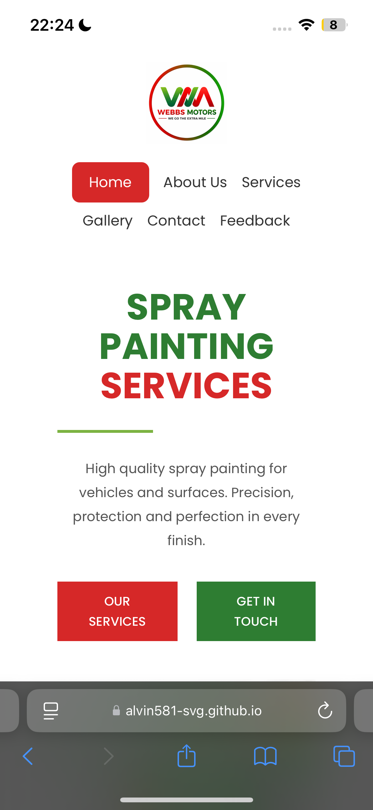It was tested on safari on a mobile device, which indicated that it also functions well on mobile devices

Future Improvements for the Website
Although the Webbs Motors website is functional, attractive, and user-friendly, there are several improvements that can be implemented in the future to make it more professional, interactive, responsive, and efficient. These improvements would enhance user experience, increase customer engagement, and improve the overall performance of the website.

1. Improve Mobile Responsiveness
One future improvement would be to further optimize the website for mobile devices such as smartphones and tablets. Although the website already uses responsive design techniques, additional adjustments can be made to ensure that images, navigation menus, buttons, and text automatically resize perfectly on all screen sizes.
A mobile-friendly website is important because many users access websites using their phones. Improving responsiveness would make the website easier to navigate and more visually appealing on smaller screens.

Possible Improvements:
- Optimize images for smaller screens
- Improve spacing and alignment on phones
- Use flexible layouts with CSS Grid and Flexbox

2. Add Animations and Interactive Effects
The website can be improved by adding modern animations and interactive effects. These features make websites more engaging and professional.
Animations can help guide the user’s attention and create a smoother browsing experience.

Possible Improvements:
- Hover effects on buttons and cards
- Smooth scrolling between sections
- Fade-in animations when content appears
- Image slideshow or carousel on the homepage
- Animated statistics or counters
These effects can be implemented using CSS animations or JavaScript.

3. Improve Website Performance
Website speed is very important because slow websites can frustrate users and increase bounce rates.
In the future, the website can be optimized for faster loading speeds by reducing file sizes and improving code efficiency.

Possible Improvements:
- Compress large images
- Minify CSS and JavaScript files
- Use optimized image formats such as WebP
- Reduce unnecessary code
- Implement lazy loading for images
Improving performance would provide a smoother user experience and improve search engine rankings.

4. Add a Database and Backend Functionality
Currently, the website is mainly static and built using HTML5 and CSS. In the future, backend technologies can be added to make the website dynamic and interactive.
This would allow the company to store customer information, manage bookings, and process feedback automatically.

Possible Technologies:
- PHP
- MySQL
- Node.js
- Firebase

Possible Features:
- Online booking system
- Customer accounts
- Login and registration
- Saving feedback into a database
- Appointment scheduling
This would make the website more useful for both customers and administrators.

5. Implement an Online Booking System
One important future improvement is the addition of an online booking or quotation request system.
Customers could:
- Schedule appointments
- Request spray painting quotations
- Select preferred dates and times
- Upload vehicle images for estimates
This would improve customer convenience and reduce manual communication.

6. Add Social Media Integration
Social media integration would improve communication between the company and customers.
The website could include:
- Facebook links
- Instagram gallery feeds
- WhatsApp contact button
- TikTok or YouTube links
This would help the business market its services more effectively and increase online visibility.

